FTF FY 2023 Performance Scorecard USAID Nepal

This Feed the Future (FTF) Performance Scorecard assesses the USAID Nepal progress toward FY 2030 Performance Targets.

# Performance Overview



The FY 2023 **On track** value is determined by drawing a line from the baseline (FY 2022) to the FY 2030 Target. For FY 2023, Performance Targets are considered **On track** if they have reported at least 90% of that value.

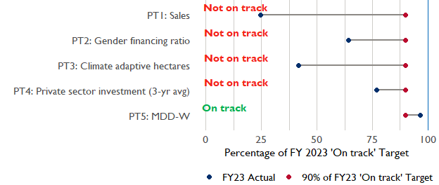

**Note:** *For Performance Target 2 (Gender financing ratio), the target is to increase financing to females for those OUs that are already achieving parity ($1).*

*For Performance Target 4 (PSI), all targets are relative to the last three years’ reporting. In future years, the interim targets may increase.*

*For Performance Target 5 (MDD-W), all FY23 actual values are also the baseline, and may have been collected in a prior year. See the detail page for more information.*

*See detailed* [*methodology document*](https://docs.google.com/document/d/13n-43ppFiGKauscQ7HaAiQDCM4DssGEgRdq2fMyTDn0/edit) *here. If you have questions, please email the FTF Data and Analytics team at* [refs.adl.da@usaid.gov](mailto:refs.adl.da@usaid.gov).

### Performance Target (PT) Details

This section shows PT scores for each applicable PT for USAID Nepal.

## Performance Target 1: Value of annual sales of producers and firms receiving USG assistance



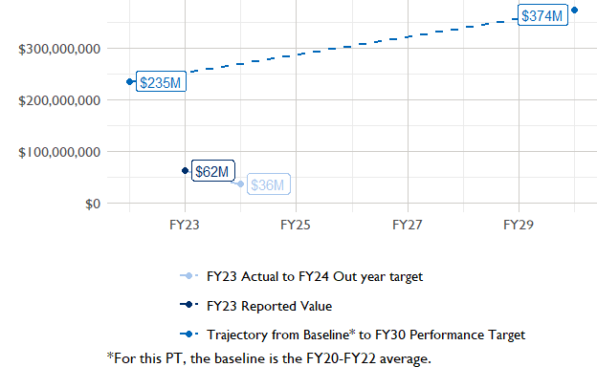

In FY 2023, USAID Nepal had 2 activities that aligned the ‘Value of annual sales from producers and firms receiving USG assistance’ (EG.3.2-26), and 2 contributed to the sales total of $62,310,000.

###### Performance Target 2: Value of financing accessed by female FTF participants per $1 of financing accessed by male FTF participants



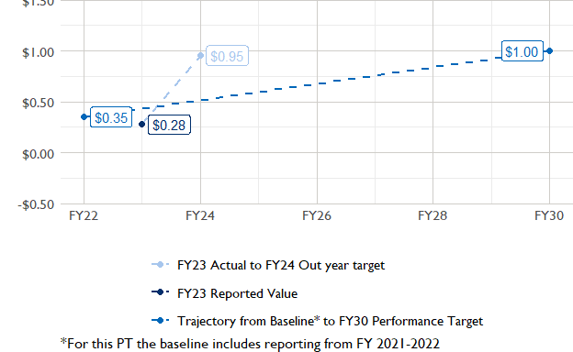

In FY 2023, USAID Nepal had 2 IMs/Activities that reported all four sex disaggregates needed to contribute to PT2. The total value of financing among all activities, regardless of disaggregates, was $9,410,000 (EG.3.2-27 total), with $9,410,000 that was disaggregated by females and males, and an additional $200,000 to ‘mixed’ firms that have both males and females, and $0 that was not sex disaggregated.

###### Performance Target 3: Number of cultivated hectares under climate adaptation/climate risk management practices and technologies with USG assistance



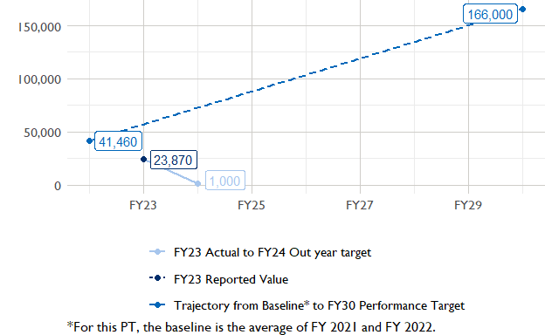

In FY 2023, Nepal had 11 activities that aligned the indicator for hectares under improved management practices (EG.3.2-25). Of those activities, 2 reported on the ‘Climate adaptation/climate risk management’ disaggregate and contributed to the OU total for this PT.

###### Performance Target 4: Value of private sector investment leveraged by the USG to support food security and nutrition



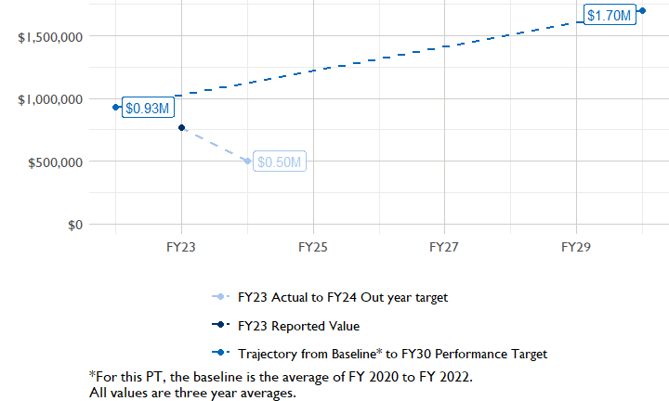

In FY 2023, Nepal had 1 activity that aligned the private sector investment indicator (EG.3.1-15/-14), ‘Value of new private sector investment leveraged by the USG to support food security and nutrition [IM-level]’, and 1 contributed to the OU total in FY 2023.

###### Performance Target 5: Percent of women consuming a diet of minimum diversity (MDD-W)



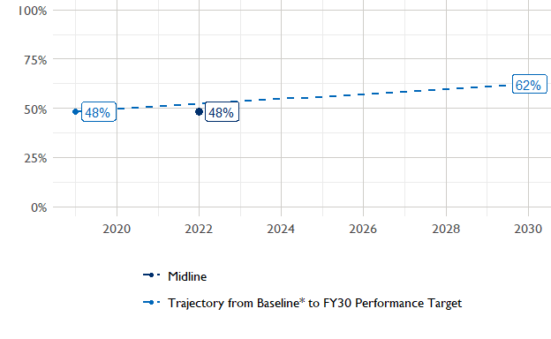

The baseline population-based survey (PBS) for USAID Nepal was in 2019 and showed that 48% of women in the ZOI had consumed a minimally-diverse diet in the previous day or night. The FY30 target is 62% percent.The most recent PBS was in 2022, and it showed that the updated value is 0.484. The following PBS is scheduled for .

### National Context

National level data was collected from the [World Bank’s Open Data portal](https://data.worldbank.org/) that measures key indicators at the national level.

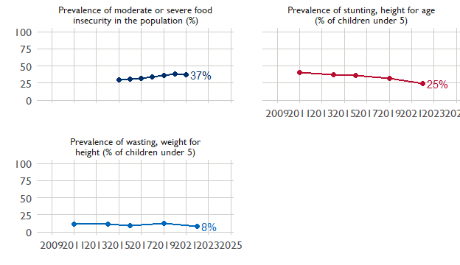

## Agricultural Transformation Index Score

The IFPRI Agricultural Transformation Index (ATI) Score is a high level indicator of the status of agricultural market systems in each country.

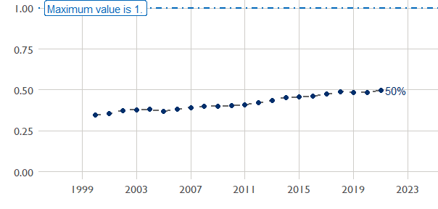

## Budget Trend

At the Operating Unit level, the Performance Targets are based in part on the FY 2024 budget request. The budget chart below includes EG.3 money only.

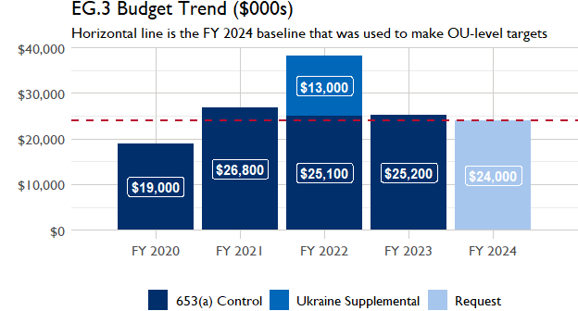

## Active Portfolio

The following activities are considered “active” based on their reporting in FY 2023 and expected FY 2024 reporting. The Analytics, Data and Learning Division defines an “active” activity as one that reported targets, actuals, or deviation narratives for the current year (FY 2023), or the next out year targets (i.e. FY 2024).

## Top Activities (Award Disbursements and Results)

This section highlights the 5 activities (out of the total 11 in the USAID Nepal (NEPAL) portfolio) that have the highest level of FY 2023 annual disbursements and highest reported values for the relevant indicators. The first table below shows activities with the highest total transaction amounts. The columns to the right indicate if these activities are reporting on relevant PT indicators.

| Award Number | Activity Code | Activity Name | FY23 Disbursements | PT1 | PT2 | PT3 | PT4 |
| --- | --- | --- | --- | --- | --- | --- | --- |
| AID-367-C-17-00001 | 1219 | Knowledge-Based Integrated Sustainable Agriculture in Nepal II (KISAN II) | $4,896,501 | X | X | X | X |
| AID-367-IO-16-00001 | 1221 | Nepal Seed and Fertilizer Project | $3,225,319 | X | X | X | - |
| 72036721C00001 | 1217 | USAID Karnali Water Activity | $935,708 | - | - | - | - |

The next table (below) shows the activities that reported the highest values for the relevant PT indicators. The total disbursements are included, if available.

| Award Number | Activity Code | Activity Name | Total Disbursements | Sales | Hectares | PSI |
| --- | --- | --- | --- | --- | --- | --- |
| AID-367-C-17-00001 | 1219 | Knowledge-Based Integrated Sustainable Agriculture in Nepal II (KISAN II) | $4,896,501 | $58,518,673 | 23 010 | $434,996 |
| AID-367-IO-16-00001 | 1221 | Nepal Seed and Fertilizer Project | $3,225,319 | $3,789,315 | 860 | NA |
| 72036721C00001 | 1217 | USAID Karnali Water Activity | $935,708 | NA | NA | NA |

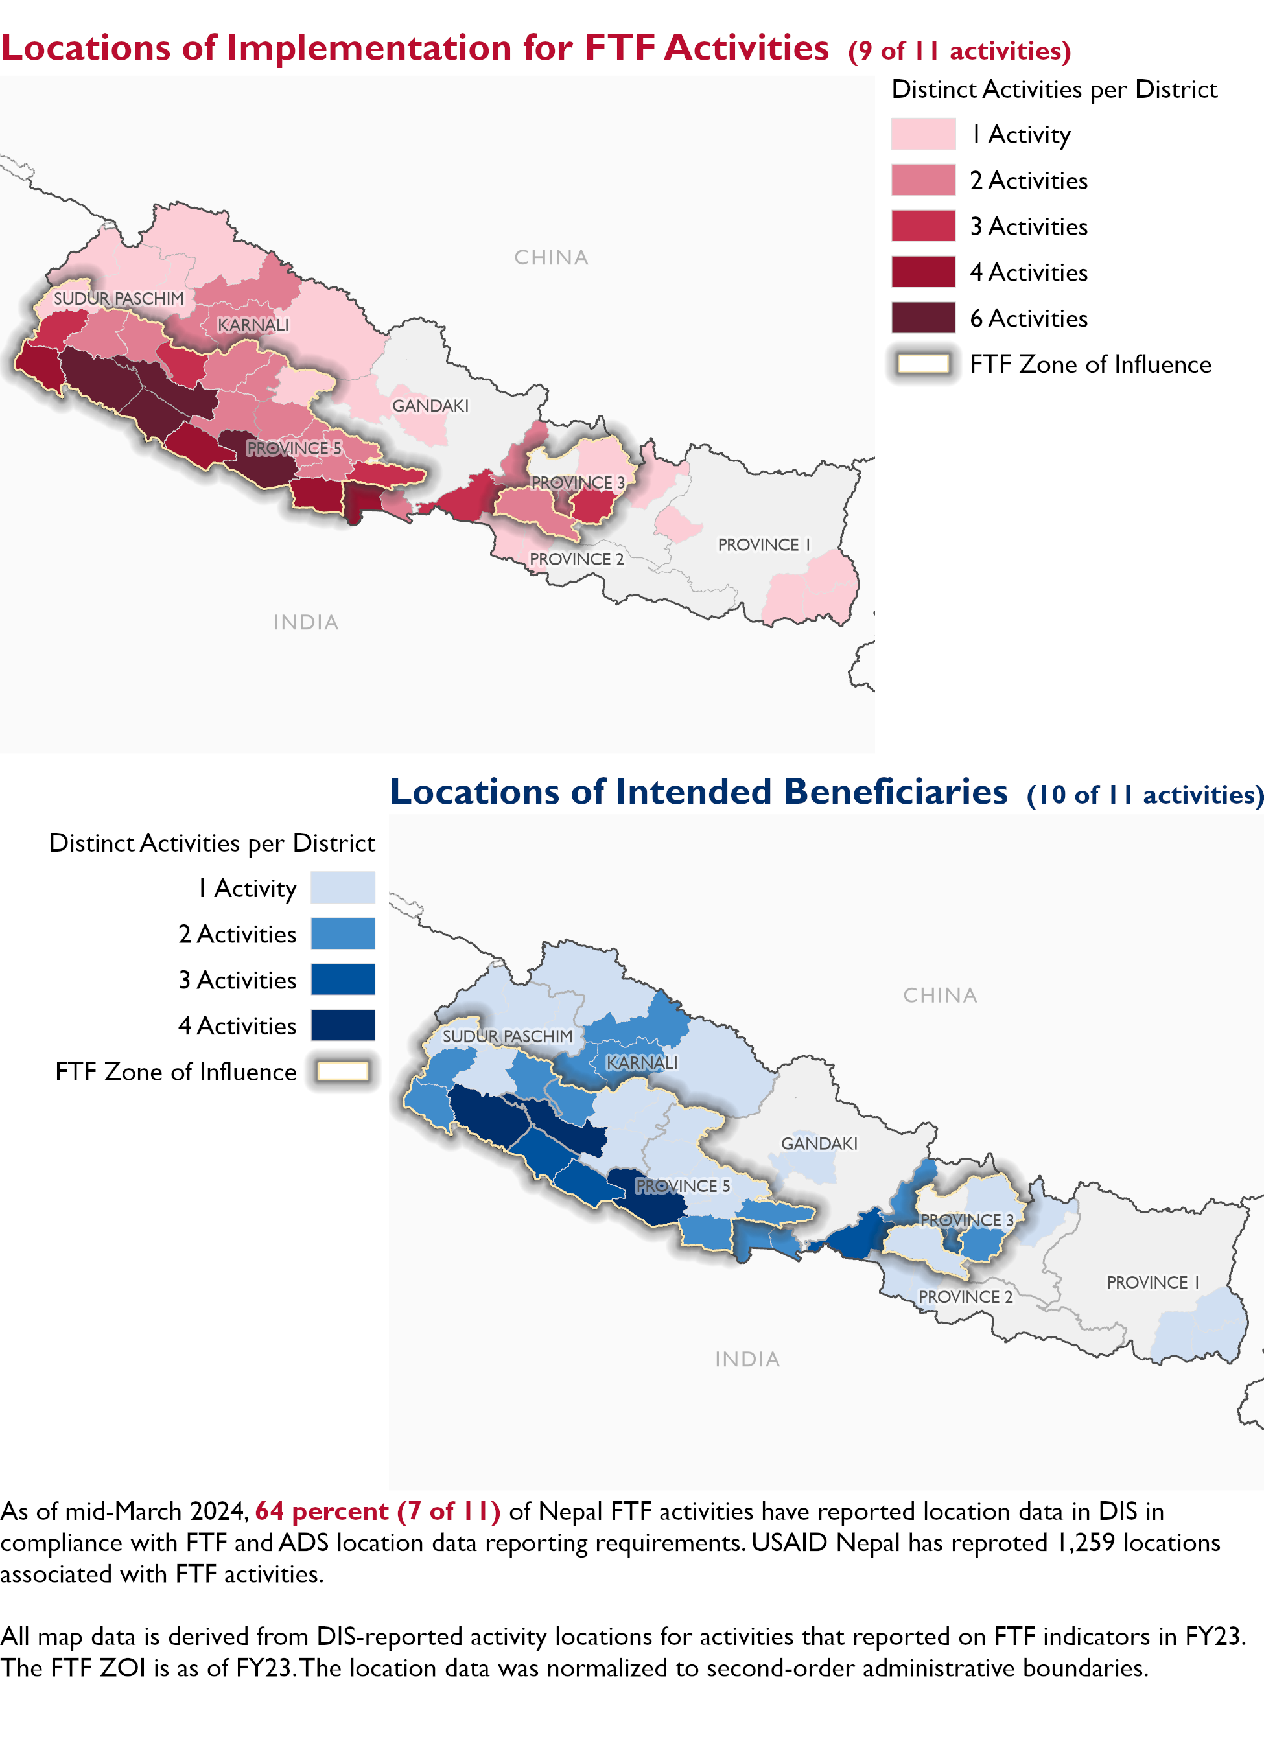

### Appendix 1: Response to “Not on track” Performance Targets

This section provides space for USAID Nepal to provide an explanation of why the following PTs are not on track and how you could adjust to be on track in the coming year(s). To help in your response(s), the relevant section of the FTF/GFS Key Issue Narrative (KIN) is provided, as it *may be* useful in drafting a responses. Note that the KIN is addressing the sum of the out year targets (FY 2023) set by the USAID Nepal activities that are reporting on each PT. The FY 2023 out year targets were set prior to the establishment of the FY 2030 Performance Targets, so the below explanations from the KIN may not apply to the Performance Target deviation.

* In Section 4 of the FTF KIN, your OU discusses FY24 and FY25 targets, while these Scorecards are addressing progress against a trajectory from historical reporting to your OU’s FY30 target. Also, the FY 2023 out year targets were set prior to the establishment of the FY 2030 Performance Targets. Therefore, the below explanations from the KIN may not apply to these FY30 Performance Target deviations.
* These responses will be used to compile a Congressional report, the GFSS Implementation Report, to discuss progress against the FTF FY 2030 Performance Targets, as mandated by the GAO.
* Only PTs that are ‘Not on Track’ require review and explanation from the OU.

Include in the response:

1. An explanation of why this target is not on track. Explanations may include that the OU/Mission was not aware of the target prior to planning activities.
2. Planned actions for ‘not on track’ targets. Planned actions may include the launch of new activities, building awareness, holding portfolio reviews, or other suggestions.

## Performance Target 1: Sales [Not on Track]

*Excerpt from FY23 KIN Section 4 to consider:*indicator is reported as an aggregate figure of results reported by Mission FtF funded activities. FY 2023 Target= $31,726,384 FY 2023 Actual = $62,307,987 FY 2024 Target = $36,426,666 FY 2025 Target = TBD Mission exceeded its FY 2023 target, deviation is explained by the cautious FT 2023 targets from KISAN II. Based on the underachievement in FY 2022 and the unseasonal rain and landslides in October 2022, KISAN II set conservative targets. Also both KISAN II and NSAF were winding down. In FY 2023, agri-inputs market normalized, and COVID-19 impacts also diminished to a great extent. Additionally, Nepal did not experience extreme climate events such as the 2022 unseasonal rain. FY 2023 turned out to be a favorable year for the farmers leading to an increased production and sales. With the focus on using climate information, especially after erratic rain and landslides in October 2022, producers increased their awareness about the usefulness of climate and risk reduction information in farming practices. As a result, there was increased demand for training and the allocation of hectares under improved management and practices that promote improved climate risk reduction and/or natural resources management with USG assistance. KISAN II expanded farmers’ access to irrigation and helped them diversify and intensify production of rice, maize, and high-value vegetables. In addition to irrigation support, farmers also received training on the use of water from irrigation. Farmers who received irrigation support and training allocated more area for increased productivity, resulting in increased sales. KISAN II also facilitated linking farmer groups with aggregators and rice mill partners to improve farmer sales. Recognizing the challenges faced by farmers in obtaining competitive prices and markets for their produce, KISAN II established a crisis communication mechanism, which facilitated direct communication between farmer groups and traders, helping farmers access alternative markets during peak production seasons. At the firm level, exceptional results are attributable to an increased demand for agri-inputs linked to the expanded cultivation areas associated with targeted commodities. Several agrovets have also started to deploy commission-based sales agents to the field. Meanwhile, rice millers began operating on a low inventory model, in which they procure and process paddy only after they receive orders from their buyers. KISAN II partnered with larger firms, increasing the average sales, of which 94 percent came from small and medium enterprises and the remainder came from microenterprises. The FY 2024 target has been set low because KII and NSAF will end in FY 2024. The newly awarded Agriculture Inputs and other FTF activities that are currently under procurement will contribute at a broadly similar scale in FY 2024 and beyond.

## Performance Target 2: Gender financing ratio [Not on Track]

*Excerpt from FY23 KIN Section 4 to consider:* indicator is reported as an aggregate figure derived from the disaggregates reported by FtF funded activities. The two flagship activities KISAN II and NSAF reported results for this indicator in FY 2023. FY 2023 Target= $0.53 FY 2023 Actual = $0.41 FY 2024 Target = $0.95 FY 2025 Target = TBD The FY 2023 results were 77 percent of the year’s target. In FY 2023, more females received agriculture loans; however, the value of loan was smaller compared to the loan taken by male participants. Women were found to be less active in commercial production and were also less likely to take loans and bear financial risk due to the increased rates on deposits as a result of the severe liquidity crunch in the first half of FY 2022/23. This liquidity crunch forced Nepal Rastra Bank to increase interest rates on deposits as well as lending. Both KISAN II and NSAF will end in FY 2024 but the newly awarded Agricultural Inputs activity will contribute to this indicator and have set outyear targets.

#### Enter USAID Nepal (NEPAL) response below:

## Performance Target 3: Hectares under climate adaptive and risk management practices [Not on Track]

*Excerpt from FY23 KIN Section 4 to consider:* indicator is reported as an aggregate figure of results reported by FtF funded activities. FY 2023 Target= 19,327 FY 2023 Actual = 23,870 FY 2024 Target = 19,000 FY 2025 Target = TBD In FY 2023 Mission exceeded its target of 19,327 (Actual: 23,870). Deviation was mainly due to KISAN II over achieving its target. Through its partnership with 24 private sector partners, KISAN II promoted new technologies, innovations, and improved practices that facilitate commercial agriculture. Adverse impacts from unexpected rains during rice and vegetables harvesting in December 2022 were not evident in 2023. FY 2023 proved to be more favorable for agriculture and farmers sought to recover last year’s losses by increasing their production area and applying improved management practices and technologies. In addition, normalization of supply chains and improved market linkages with farmer’s confidence contributed to larger production areas. KISAN II partners also worked with farmers, enabling them to cultivate larger areas of rice and maize than anticipated. The outyear targets have been set low mainly because KISAN II and NSAF which are the major contributors will come to a close in FY 2024. The newly awarded Agricultural Inputs activity will contribute to results in FY 2024 and outyears.

#### Enter USAID Nepal (NEPAL) response below:

## Performance Target 4: Private sector investment [Not on Track]

*Excerpt from FY23 KIN Section 4 to consider:* indicator is reported as an aggregate figure of results reported by FtF funded activities. FY 2023 Target= 19,327 FY 2023 Actual = 23,870 FY 2024 Target = 19,000 FY 2025 Target = TBD In FY 2023 Mission exceeded its target of 19,327 (Actual: 23,870). Deviation was mainly due to KISAN II over achieving its target. Through its partnership with 24 private sector partners, KISAN II promoted new technologies, innovations, and improved practices that facilitate commercial agriculture. Adverse impacts from unexpected rains during rice and vegetables harvesting in December 2022 were not evident in 2023. FY 2023 proved to be more favorable for agriculture and farmers sought to recover last year’s losses by increasing their production area and applying improved management practices and technologies. In addition, normalization of supply chains and improved market linkages with farmer’s confidence contributed to larger production areas. KISAN II partners also worked with farmers, enabling them to cultivate larger areas of rice and maize than anticipated. The outyear targets have been set low mainly because KISAN II and NSAF which are the major contributors will come to a close in FY 2024. The newly awarded Agricultural Inputs activity will contribute to results in FY 2024 and outyears.

#### Enter USAID Nepal (NEPAL) response below: